Homework 2 Report

# (Yunke Tian 109929662)

# Question 1

The CDF plots for the 4 configuration are as follows:

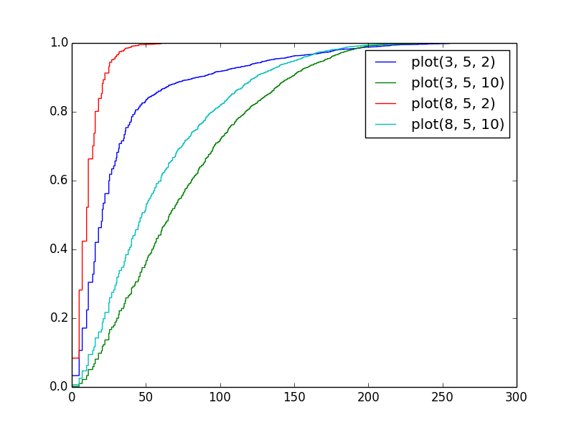

From the figure we can easily see that:

1. The larger number of transmitters, the less error.
2. The smaller noise standard deviation, the less error.

# Question 2

The heatmaps for different resolutions are as follows:

(Note 1: I didn’t run with resolution k = 1, because it takes too much time to run (more than 30 hours, maybe my algorithm is not optimized.

Note 2: For accuracy calculation, I used accuracy = 120 – mean(error). I tried accuracy = 1 / mean(error), which however didn’t perform well.

Note 3: Dark blue means more accuracy, while light blue means less.)

../../../../Downloads/hw2img/heatmap_reso_5.png ../../../../Downloads/hw2img/heatmap_reso_10.png ../../../../Downloads/hw2img/heatmap_reso_15.png ../../../../Downloads/hw2img/heatmap_reso_20.png

k = 5 k = 10 k = 15 k = 20

# Question 3

1. Smaller noise variance results in higher localization accuracy. Placing additional transmitters will also improve localization accuracy.
2. We can see that when noise variance becomes larger, additional transmitters improves the accuracy less. If noise is larger than a threshold, additional transmitters will have very little improvement on accuracy.
3. For a given setting, there’s an optimal K which gives the best localization accuracy. But according to results in Question 2, we can see that the difference between accuracy from different K is not big, and there’s no obvious pattern of K’s influence on accuracy.